**Laboratory Quiz – Software Version Control, Python, and Linux CLI**

**Total Points: 50**  
**Environment Requirement: Use the VM DEVASC Virtual Machine**

**Instructions**

* Complete all tasks in the VM DEVASC environment.
* You must use Git and GitHub to track, manage, and submit your work.
* Create a **private GitHub repository** named lab-quiz-<your_name>.
* Push all relevant files and commits to this repository.
* At the end of the lab, submit your **repository link** to your instructor or learning platform.

**Part 1: Git Version Control (20 points)**

Follow Git version control practices:

1. Create a new local directory lab_quiz_<your_name>.
2. Initialize a Git repository using git init.
3. Create a README.md using nano that describes the project’s purpose.
4. Add and commit it with the message: "Initial commit with README".
5. Create and switch to a new branch named develop.
6. Create a file networking_notes.txt and add 5 bullet points on common networking problems.
7. Commit the file and merge the develop branch into main.
8. Save commit logs to git_log.txt using git log > git_log.txt.
9. Push all commits to your **private GitHub repository** lab-quiz-<your_name>.

**Part 2: Python Script – Personal Info & Networking Issue (15 points)**

Create a Python script info_network.py that:

* Prints your **full name**, **student ID**, and the **current date and time**.
* Prompts the user to describe a **networking issue**.
* Saves the response into network_issue.txt.

Run the script in the terminal and commit both .py and .txt files to your repository.

**Part 3: Linux Command Line Manipulations (15 points)**

In your working directory:

1. Create a folder called backup/ and **copy** network_issue.txt into it using cp.
2. Use chmod to make info_network.py **executable by the user only**.
3. Use the cut command to extract the first line of network_issue.txt into a new file issue_summary.txt.
4. Use zip to compress the lab_quiz_<your_name> folder into lab_quiz_<your_name>.zip.
5. Use ls -l and redirect the output to a file named permissions.txt.

Commit and push all the resulting files:

* backup/network_issue.txt
* issue_summary.txt
* lab_quiz_<your_name>.zip
* permissions.txt

**Submission Requirement**

* All files must be pushed to your **private GitHub repository** named lab-quiz-<your_name>.
* Make sure to commit frequently with meaningful messages.
* Share your **repository URL** with your instructor for grading.

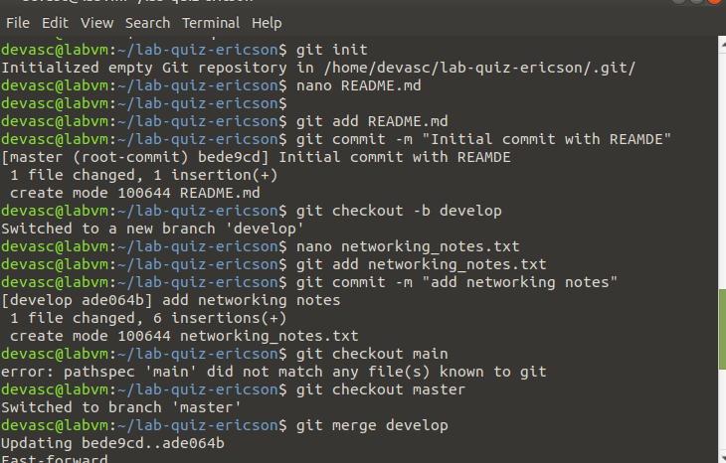  
  
  
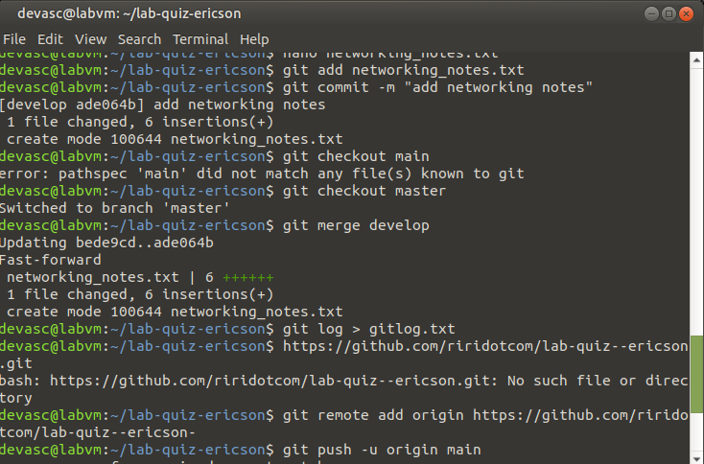  
  
  
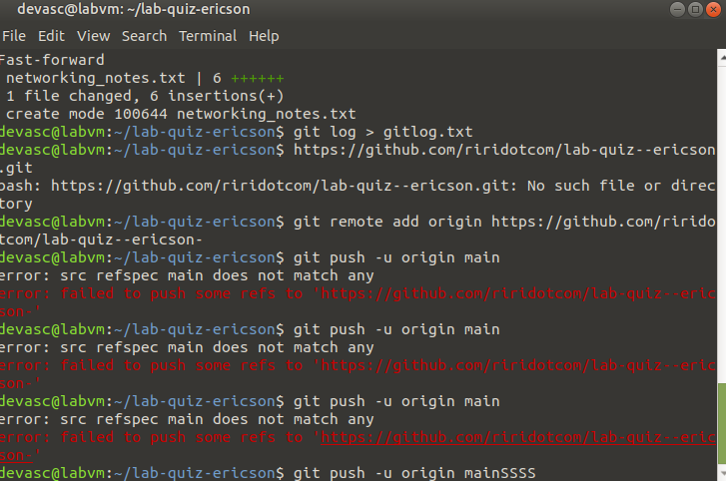  
  
  
  
2.  
